Model 4160
Connector, BNC (Female), Bulkhead
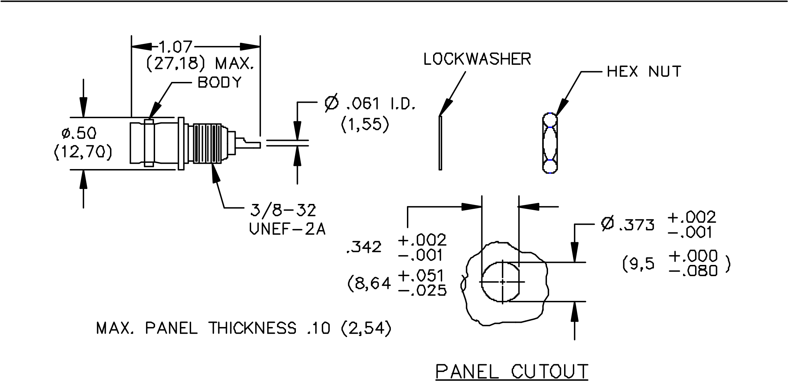

FEATURES:
• Connector meets the interface requirements of MIL-STD-348

MATERIALS:
Body and Fittings – Brass, Tarnish Resistant Plating
Center Contact – Gold Plated Beryllium Copper
Dielectric: PTFE
Marking: “Pomona 4160”

RATINGS:
Operating Voltage: Shield/Earth: 30VAC/60VDC Max.
Inner Conductor/Shield: 500VRMS Max.
Operating Temperature: -65ºC to +165ºC
Nominal Impedance: 50 Ohms

ORDERING INFORMATION: Model 4160
Parts are packaged one per bag, unassembled.
All dimensions are in inches. Tolerances (except noted): xx = ±.02” (,51 mm), .xxx = ± .005” (,127 mm).
All specifications are to the latest revisions. Specifications are subject to change without notice.
Registered trademarks are the property of their respective companies. Made in USA

5_{/30/02 SY/EH/LS}
S:\Engineering\Release\DataSheets\FlukeDataSheet\d4160_1_02.doc Page 1 of 1

